Practical No 7

**John The Ripper**

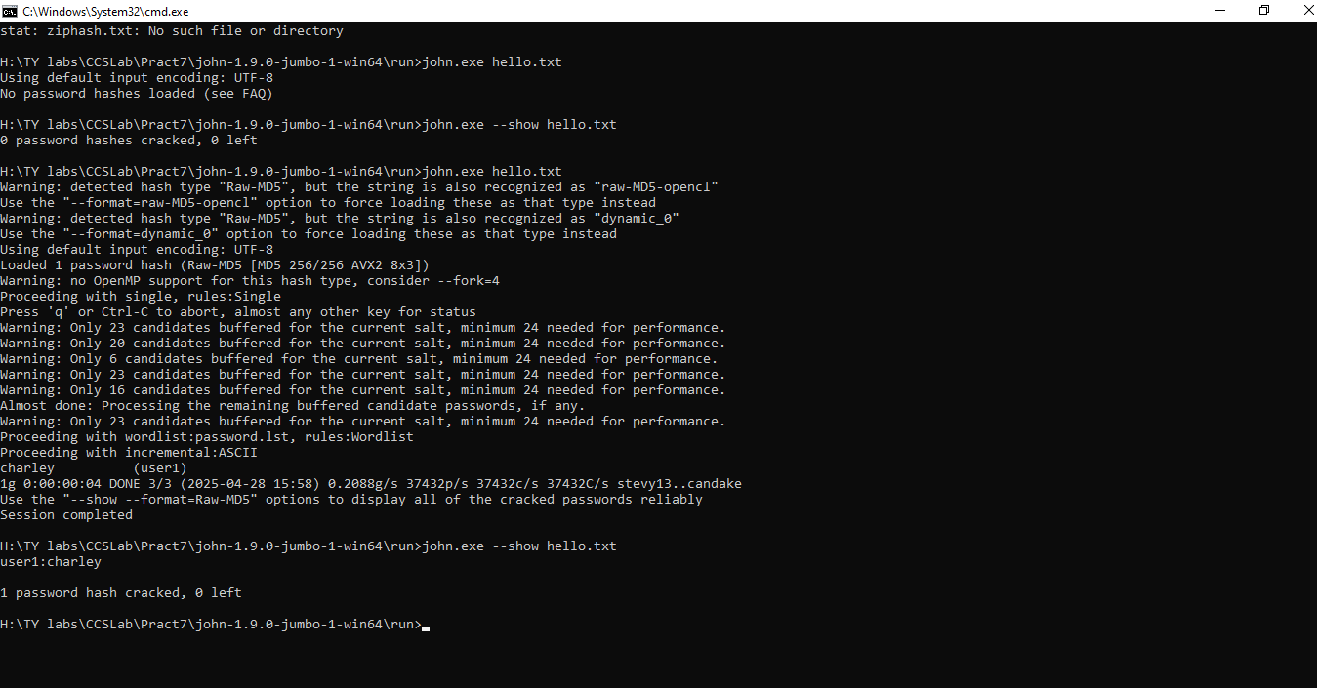

John The Ripper

>zip2john.exe hello.zip>ziphash.tx

>john.exe hello.txt

>john.exe --show hello.txt

**HashCat Tool**

>hashcat.exe -m 0 hello.txt

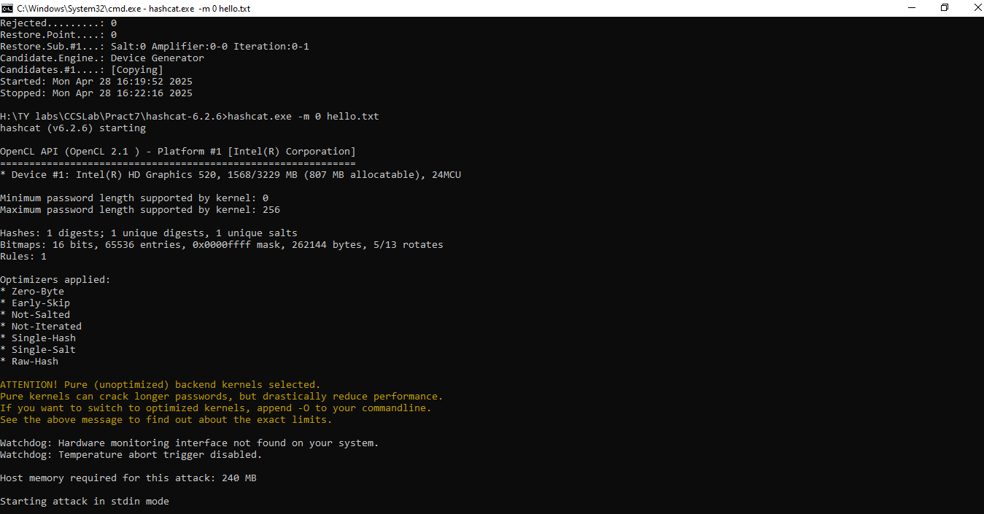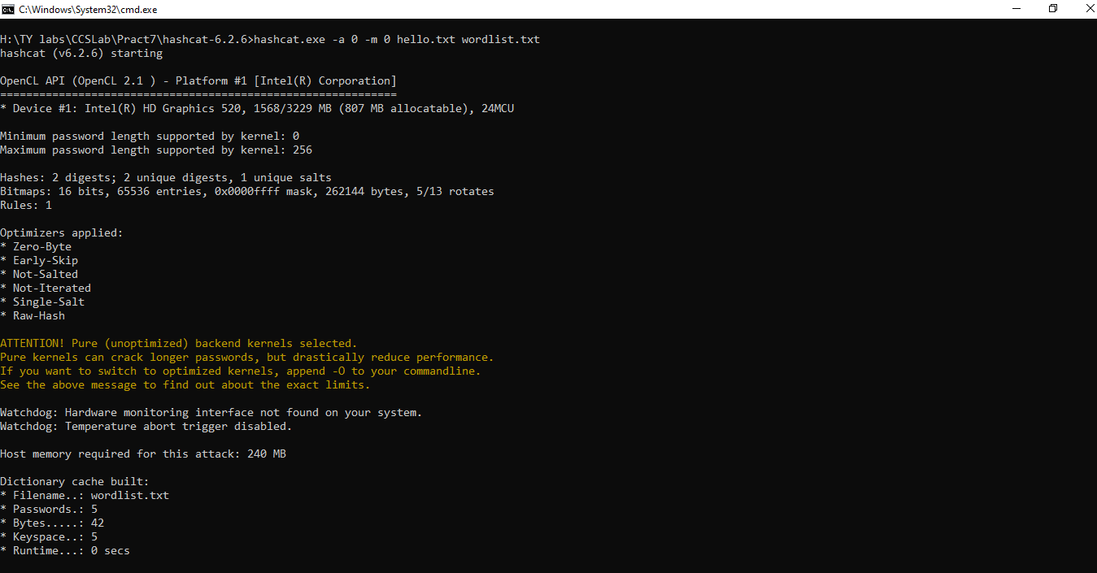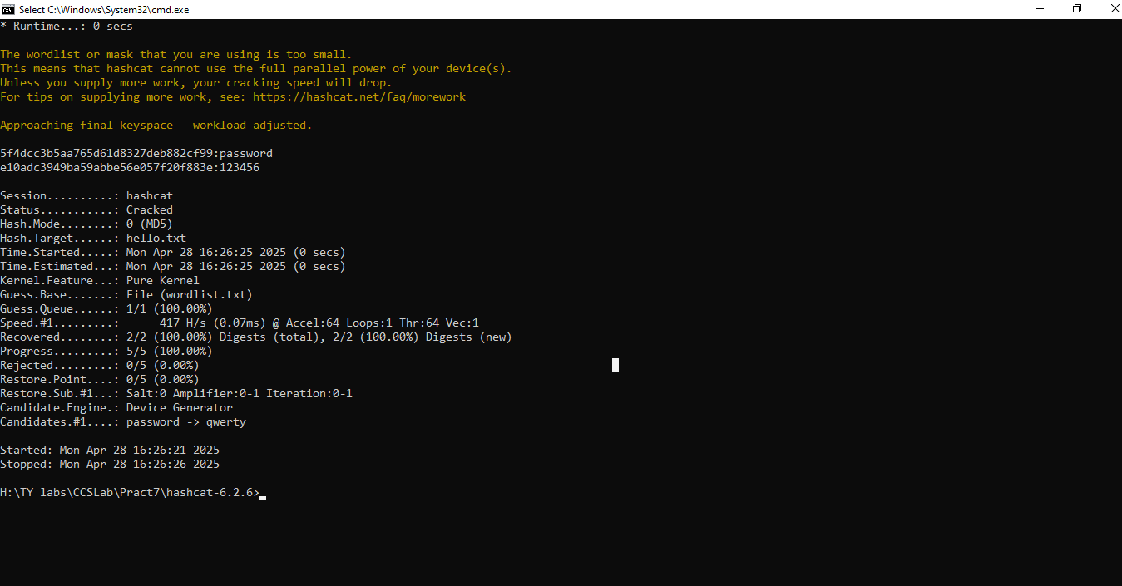

**KRyLack ZIP Password Recovery** is a simple GUI-based tool designed to recover lost or forgotten passwords from ZIP archives. It’s especially beginner-friendly and requires no technical background to use.



